MATHEMATICS SPECIALIST

MAWA Year 12 Examination 2017

Calculator-free

Marking Key

© MAWA, 2017
Licence Agreement
This examination is Copyright but may be freely used within the school that purchases this licence.
- The items that are contained in this examination are to be used solely in the school for which they are purchased.
- They are not to be shared in any manner with a school which has not purchased their own licence.
- The items and the solutions/marking keys are to be kept confidentially and not copied or made available to anyone who is not a teacher at the school. Teachers may give feedback to students in the form of showing them how the work is marked but students are not to retain a copy of the paper or marking guide until the agreed release date stipulated in the purchasing agreement/licence.

The release date for this exam and marking scheme is
- the end of week 1 of term 4, 2017

Question 1

Solution
Separating variables gives that
and so
Since when then.
Hence

Specific behaviours
separates variables correctly
integrates each side correctly
evaluates the constant correctly

Question 2

Solution
The function is odd as .
Now as clearly have that .
Also
which indicates turning points at . Also.

Specific behaviours
identifies correct behaviour for large values of
differentiates using the quotient rule
identifies the turning points
draws a neat sketch with a function with a properly identified max/min and being odd in

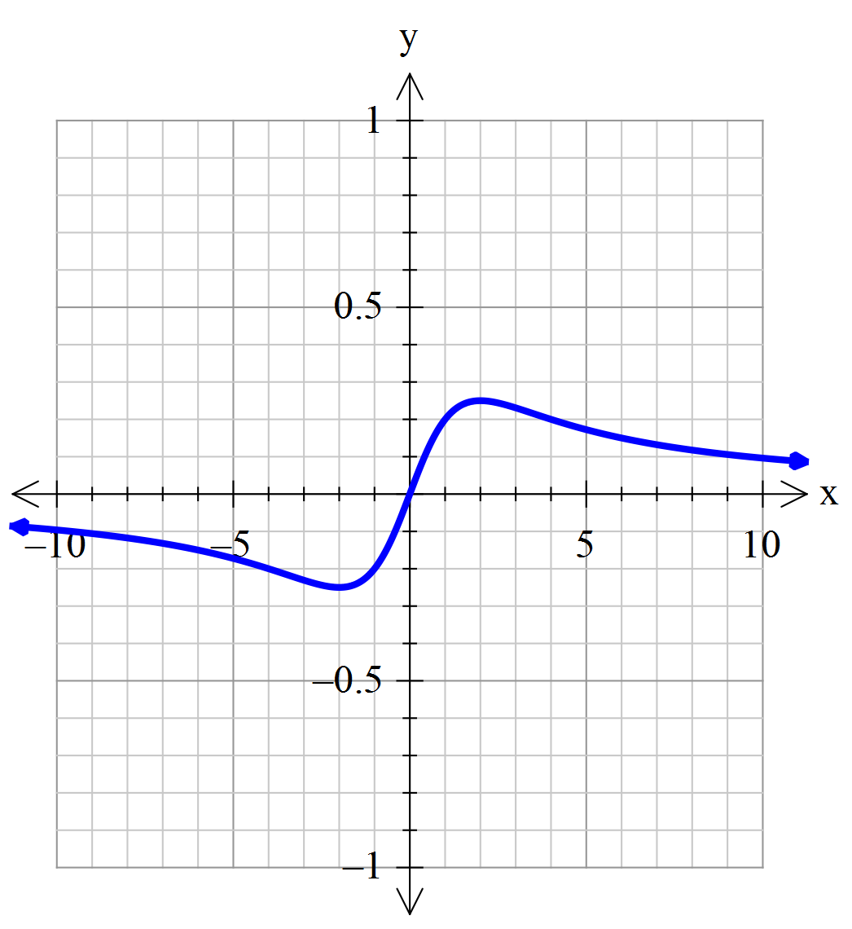

Question 3 (a)

Solution
Curve cuts the axis where so
Hence P and Q are the points

Specific behaviours
writes down the correct criterion for determining the points P and Q
solves for and hence the two points

Question 3 (b)

Solution
Differentiating implicitly gives
Where have so the two tangents are parallel.
Specific behaviours
differentiates correctly (one mark for each implicit term)
shows the gradients are the same at the two points P and Q
deduces that the two tangents are parallel

Question 3 (c)

Solution
If P=(3,0) then the y co-ordinate of R is approximately

Specific behaviours
applies increments formula correctly
deduces approximate value of the required co-ordinate

Question 4

Solution
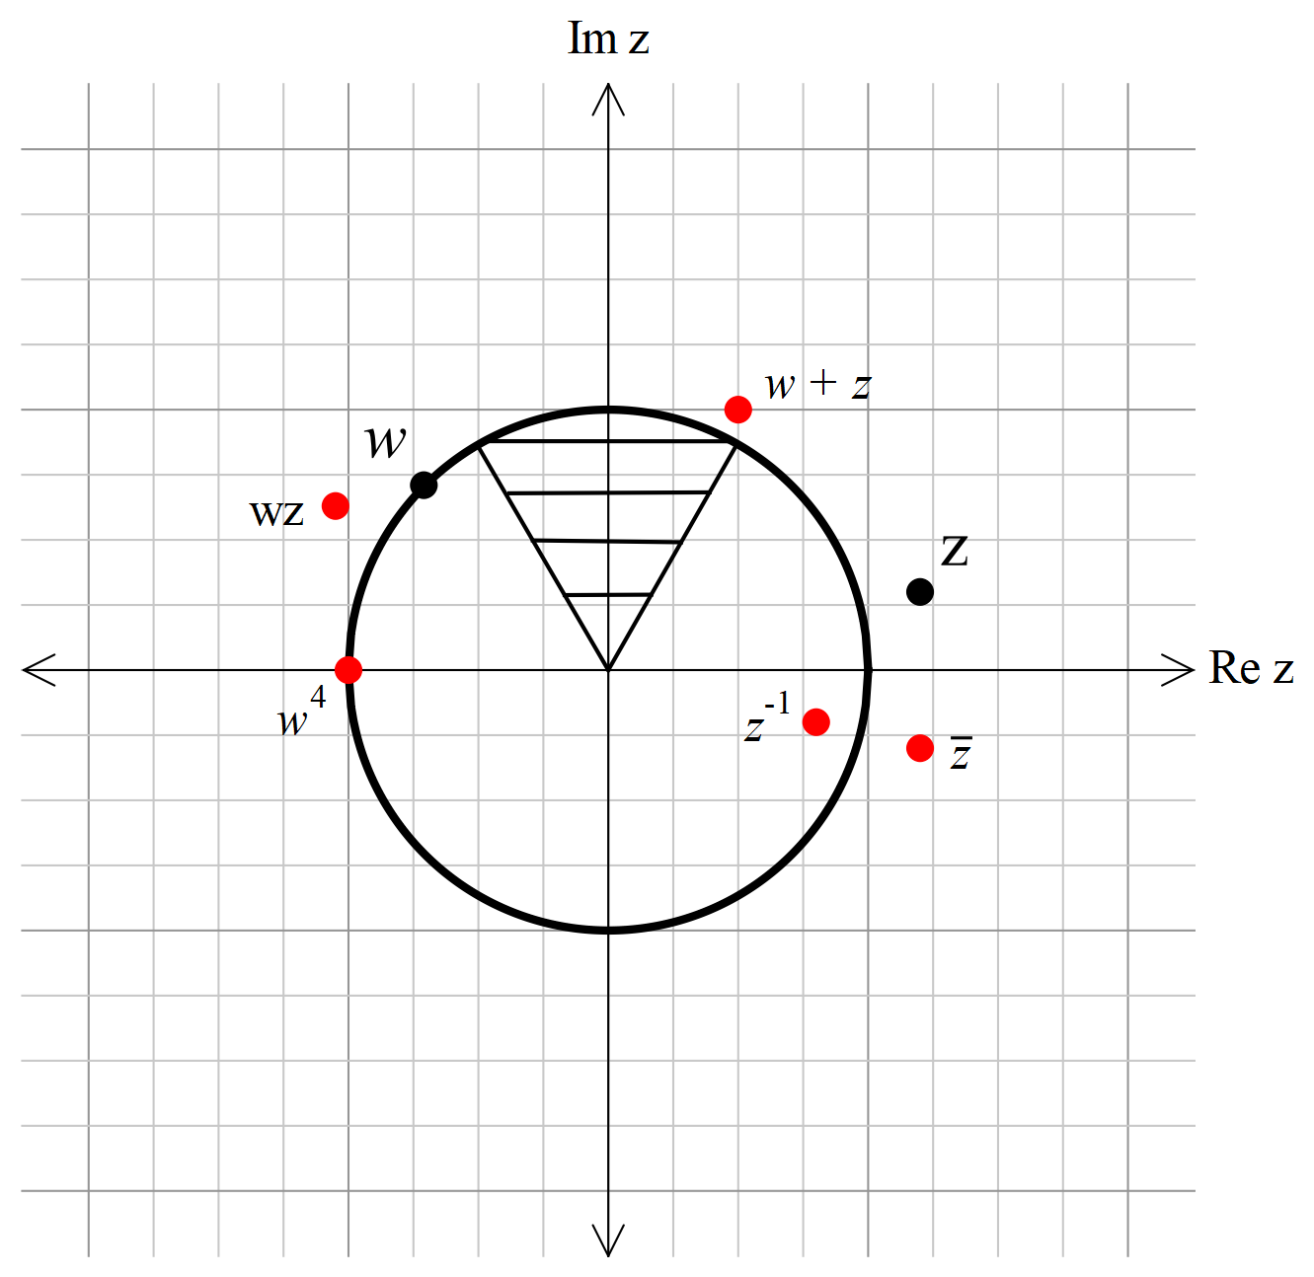

Specific behaviours
locates each of in correct position
shows the correct boundary rays
shows the arc of the unit circle on the boundary

Question 5 (a)

Solution
Specific behaviours
converts the integrand into the form involving
uses the trigonometric identity to write in terms of
integrates correctly (with no penalty for omitting the constant)

Question 5 (b)

Solution
Specific behaviours
expresses in terms of
integrates correctly
evaluates the limits correctly

Question 5 (c)

Solution
Then

Specific behaviours
changes variable to u in integral
anti-differentiates with respect to u
evaluates correctly

Question 5 (d)

Solution
Then
Hence
Thus the integral equals 1 if
Specific behaviours
changes variable to v in integral
evaluates the integral correctly
deduces the correct value of Q

Question 6 (a)

Solution
From the formula sheet
Specific behaviours
obtains correct answer

Question 6 (b)(i)
Solution
Since , 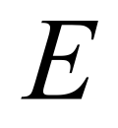 decreases by a factor of if 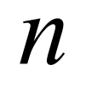 is doubled.
Specific behaviours
draws the correct conclusion

Question 6 (b)(ii)
Solution
Since and increases as the level of confidence increases,  increases if the level of confidence increases.
Specific behaviours
draws the correct conclusion
Question 6 (b)(iii)
Solution
Since ,  doubles if 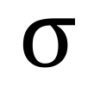 doubles.
Specific behaviours
draws the correct conclusion
Question 6 (c)(i)
Solution
This statement is false.
Reason: it is possible that all ten confidence intervals contain 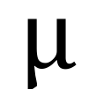 (or none even!)
Specific behaviours
obtains correct answer
gives a valid reason
Question 6 (c)(ii)
Solution
This statement is false
Reason: If the underlying population is normal and the sample size is large enough, the confidence interval will be smaller than any interval that contains 95% of the underlying population
Specific behaviours
obtains correct answer
gives a valid reason

Question 7 (a)

Solution
Specific behaviours
determines in terms of
uses
evaluates

Question 7 (b)
Solution
Specific behaviours
states the equation in vector form
states the equation in parametric form

Question 7 (c)
Solution
Specific behaviours
calculates the vector product correctly (one mark if one component is incorrect)

Question 7 (d)
Solution
Specific behaviours
uses vector as the normal
states the correct equation of the plane
© MAWA, 2016
This examination is Copyright but may be freely used within the school that purchases this licence.
- The items that are contained in this examination are to be used solely in the school for which they are purchased.
- They are not to be shared in any manner with a school which has not purchased their own licence.
- The items and the solutions/marking keys are to be kept confidentially and not copied or made available to anyone who is not a teacher at the school. Teachers may give feedback to students in the form of showing them how the work is marked but students are not to retain a copy of the paper or the marking guide until the agreed release date stipulated in the purchasing agreement/licence.
Published by The Mathematical Association of WA
12 Cobbler Place, MIRRABOOKA 6164.

© MAWA, 2016
This examination is Copyright but may be freely used within the school that purchases this licence.
- The items that are contained in this examination are to be used solely in the school for which they are purchased.
- They are not to be shared in any manner with a school which has not purchased their own licence.
- The items and the solutions/marking keys are to be kept confidentially and not copied or made available to anyone who is not a teacher at the school. Teachers may give feedback to students in the form of showing them how the work is marked but students are not to retain a copy of the paper or the marking guide until the agreed release date stipulated in the purchasing agreement/licence.
Published by The Mathematical Association of WA
12 Cobbler Place, MIRRABOOKA 6164.

